**UNIT 03 ENGINEERING SCIENCE**

Student Name:

Student ID:

# Introduction

The quantitative methods are described as those methods in which the light is thrown on the measurements and calculations on titles related to mathematical operations and statics, analysis of data, and study of that data which is collected through some surveys and reports. This is the data that is pre-existing and using some operations. This quantitative data is the collection of the pre-existing data and then the research of the collected data for some further use.

The data is consist of numeric and other logical analysis which is collected from different research sites. Whereas the case of computational methods these are implemented in various science such as physical, biological, and statistics. The computational methods are implemented on series and spectral analysis, component analysis, filtering methods. They are also implied in digital image processing and compression.

The qualitative data is defined as the data type which is used to collect the data and then characterizes and approximates the quantities.

This type of data is collectively observed and characterized and have a quantity of non-

numerical and that is collected through different projects. This data is further categorized according to their properties and categories.

This data describes the characteristics and qualities of the collective data module. This is the collection of observations, questions, and other notes of the collected data. This is further classified as nominal and ordinal data.

Whereas in the case of quantitative data, a certain problem is analyzed and then that problem is further used as the research and other works. This can be usually used in the numeric scale as well which is further includes the rating and scale of the data.

This type of data is defined as

Ordinal

Nominal

Interval

Ratio (Holton et. al, 2016).

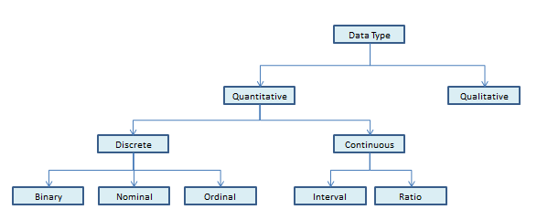

Figure 1 Qualitative and Quantitative data

## M1:

Scientific methods are used to find and explore the answers to all the experimental procedures. The scientific methods are the key steps that are used to keep the information and updates of the required information in a backup. The procedure involves careful observations, methods, foundations, and their implementation in the procedure. It further involves experimental observations and implementations and formulations in the process.

The scientific method and allocation use a standardized method which further manages the standard of the firm. There are five different types of testing methods which are used in scientific methods

**Inquiry**

The inquiry is the basic, simple, and obvious procedure to determine the demands of the external user and then that information is used by the key staff accordingly. These methods are used and important to let the system know about the demands and requirements of the user and then work accordingly.

For example to ask the owner of any certain firm about their firm and their financial needs.

This inquiry results in the better development of the project and more appropriate towards the requirement.

**Examination and Inspection**

The examination and inspection lead to the check the work and to get the updates accordingly which further leads to consistency of the work and to check the file type and its management.

These inspection methods are used to determine any fault in the running program or any changes which need to be done in the project.

**Observation**

This is the simple step and effective step to determine the task and to observe the fault in the task.

This step involves the observation, management, steps checking off the task.

This observation also involves the checking of the mechanism and procedure of the program or any document.

**Re-performance**

The re-performance is done when there is a certain fault is coming in the assigned task and that results in the failure of the task and that further leads to the re-performance of the task.

The observation, analysis, and calculations of the program are failed to provide the complete quality check then the re-performance is scheduled.

**CAAT- Computer Assisted Audit Techniques**

This specific technique is used when there is a large bulk of data is assigned to analyze. The situation becomes quite challenging to analyze this bulk data so further software is designed to analyze the data and then that is characterized for further use (Handoko et.al, 2018).

## D1:

Examination of given scientific data using the qualitative analysis and quantitative analysis.

The analysis of the given data using the procedure of computational methods involves statistical and mathematical operations which are neutral networks, tools from wavelet, and physical analysis that is used to develop and create better efficiency for the operational algorithms and programming.

This also involves a combination of certain theories in terms of real-life data and Matlab algorithms and their examples. The introduction of mathematical and statistical methods is used to implement the calculations and data analysis and its management with the applications involved in biological, medical, and other economic fields (Melgar et. al, 2018).

# LO2

## P3:

The support beam and its reaction have two supports at both ends the one at the one end are pinned support and the other one is roller support. In this case, the beam is prohibited to move but it can rotate freely. After the removal of any support, it will disturb the inter alignment of the body. So such types of structures that have zero movements and no redundancy are said to be critical and determinant bodies.

The uniform distribution of the load is equally distributed across the whole surface on any particular material such as any beam or slab surface. The given magnitude of the given load remains uniform through the complete ongoing process.

## P4

Archimedes principle is defined as the law of floatation or the objects which float. This is the physical law for floatation which is termed buoyancy. This is first discovered by the Greek mathematician who stated the fact that anybody or object which is submerged in the fluid is when at rest is acts as an upward force. And when we calculate the magnitude that is directly proportional to the mass of the fluid which is removed or dispatched from the body. This amount equals the mass of the object which is fully inside the given fluid or that of the fraction of the mass below the surface of the object which is partially present in the fluid body.

This force equals to the body which is floating and that is opposite in the direction when the body neither rises and nor goes down .

## P5:

The state of any material is something that can be changed when it will be exposed to any other external environment and force. So it is obvious that if we change the external environment and the physical conditions of the material it leads to a sudden change in its state as well.

Taking the case as when we will change the physical conditions of all the three states be is solid, liquid, gas. The change in temperature and pressure will give us some observable results.

When we will apply external thermal energy the increment in the temperature will be seen. When we will change the state of solids by applying thermal energy we will see the melting of the solid material and the same as we will apply the thermal pressure we will see the state of liquid is converted into gas. And when we will apply the temperature change in gas we will get liquid again (Kaya.M, 2016).

## M2:

The principle of d’alembert’s is to reduce error in case of dynamics to reduce error in statistics.

The other law states that when there is a force which is acting on a body adds the negative of mass m and then the increase in speed of the object is zero.

F-ma=0

This states that in when there is the object who is in equilibrium under certain movements of forces in real and the mass is fictitious is –ma. This applies the force which is fictitious as the inertial force or the force which is reversed.

## D2:

The efficiency of the thermal heat transfer process is said as the measure of usage of thermal energy when used by a certain device. There are so many examples of thermal efficiency such as the steam engine, boiler, furnace, etc. So, the thermal efficiency of the heat engine is calculated as when that energy is converted into work. Thermal efficiency is the measure of the effective performance of a device which is using thermal energy. The devices which use thermal energy are steam turbine, boiler, furnace, refrigerator, combustion engine, etc. when taking the example of heat engine, the calculation of its thermal efficiency is termed as energy which is addition done by heat which thus converts into the network output which is performed by the system is defined as its thermal energy.

# Lo3

## P6:

The structural properties of metals are rigid and it is the most widely used state that completely connects the string to the tight packing of the atoms and the interconnected bonds between them. The connectivity of the metals plays completely depends upon the coordination between them. The atoms touch each other have six other atoms who touch each other and then they have three atoms they are touching each other with another three layers and which becomes the connection of 9 atoms. There will be some metals which are packed loosely have 8 touching neighbors. Another case consists of the crystal grains of metals in which the atoms are tightly packed with each other and forms a wall of crystals.

Whereas looking, on the other hand, the case on non-metals the non-rigid property of them can be turned into any shape. They do not conduct heat and electricity, nor they have appropriate melting and boiling points. They possess a high amount of ionization and electronegative energies which is due to their poor conductivity because of the low amount of ionization property. The chemical reaction and reactivities are higher than those of the other state.

## P7:

The degradation of materials takes place due to several reasons such as

**Rust expansion**

The rust expansion is defined as when there is a metal surface preferably iron which is exposed water and becomes rust. But after the rust is expanded and cracked that is the procedure of rust expansion.

**Uniform corrosion**

When their moisture present in the environment along with any water exposer, it leads to the initiation of the procedure of corrosion. This is the mechanism of uniform corrosion.

**Pitting and crevice corrosion**

In this case, the metal objects are subjected to oxidization and then eventually becomes unstable due to halides.

**Wild decay filiform corrosion**

In this case, the welding of the metals likely stainless steel is not conducted properly by the user that ultimately weld and corrode the steel rapidly.

**Selective leaching**

This is a slow process in which the corrosion starts affecting the alloy. The quality of the alloy matters here that prevent the metal to not degrade.

**Erosion corrosion**

Erosion corrosion is damage that is done when a fluid that is coming from a very high speed hits the material by which the alloy and metal get destroyed. Speed reduction and strong alloy would be better to use.

**Carbon fiber damage**

When a substance is exposed to the carbon fiber ultimately results in the degradation of the substance from the blisters of a white compound which is carbon that results in the formation of white particles on a surface.

**Stress corrosion cracking.**

When substances like brass or any other that comes in contact with higher tensile strength and aggressive environment result in the degradation of the material.

## M3:

When the strain of the object lacks behind the stress that is defined as elastic hysteresis. The force which is working on an object and applied to it does not change simultaneously concerning stress that condition causes elastic hysteresis.

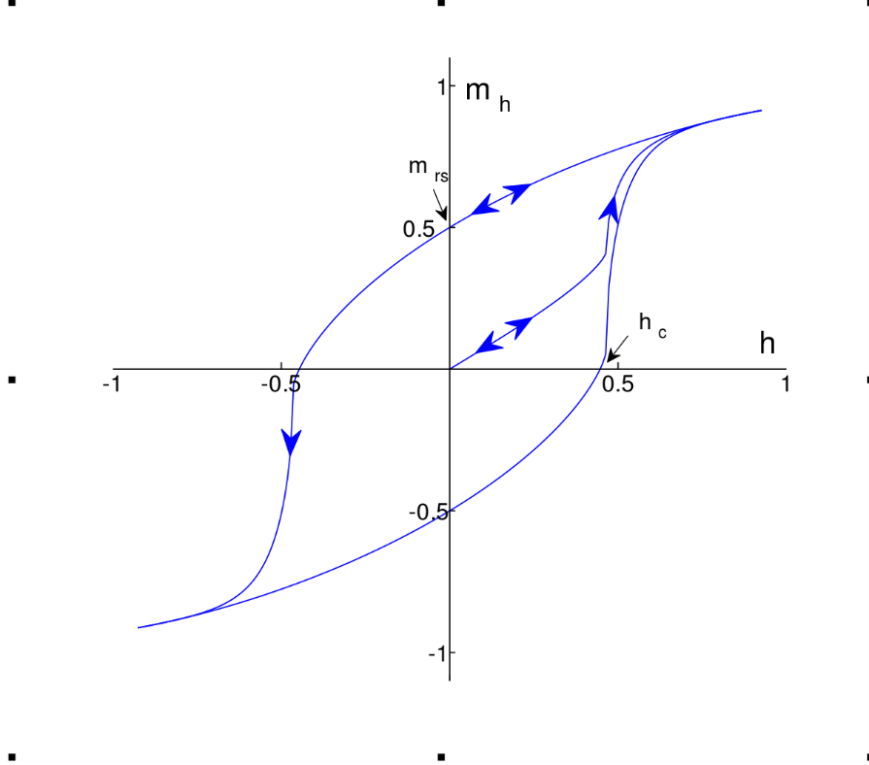

Figure 2 Elastic Hysteresis

In the case of electric hysteresis, the consumption of power matters in that. The lack of power or between the change such as the high or low consumption of power that makes the case of increment and decrement of power is defined as electrical hysteresis.

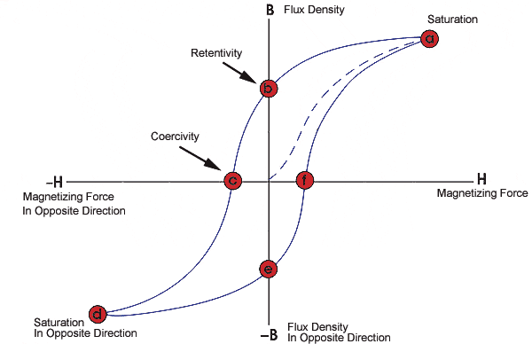

Figure 3 Electric hysteresis

In simple words, magnetic hysteresis is defined as when a ferromagnet object is placed and the external magnetic field is applied to it which lacks behind the magnetic force is termed as magnetic hysteresis.

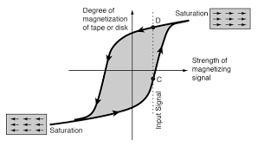

Figure 4 Magnetic hysteresis

Hysteresis is defined as the state of a system that is variable concerning its movement. When an electric or magnetic field keeps changing the movement concerning the field that shows the observable curve in the graph. When there is a change of the values concerning the change in direction and other magnetic fields shows the variation in the graph. This occurs in the case of ferroelectric and ferromagnetic fields. They are defined as the mechanism by which certain specific materials are attracted to magnets. Example iron or any other metal.

## D3:

Taking another example which is the calculation of thermal energy of the refrigerator which is the efficiency of the net heat output for heating or the energy is used to remove cooling divided by the energy which is consumed. This will develop the efficiency expression which is when the heat engine receives heat from the external environment and releases the heat to the environment only. This equation gives the relationship of the equation heat load and dissipation for the heat to power to power consumption. This provides better and upgraded ways to design and analysis of heat exchangers and their networks. The thermal efficiency is fluctuating which is in between that of 0 – 100%